CS 3600 Project 3 Wrapper

CS3600 - Fall 2022

Due November 7th 2022 at 11:59pm EST via Gradescope

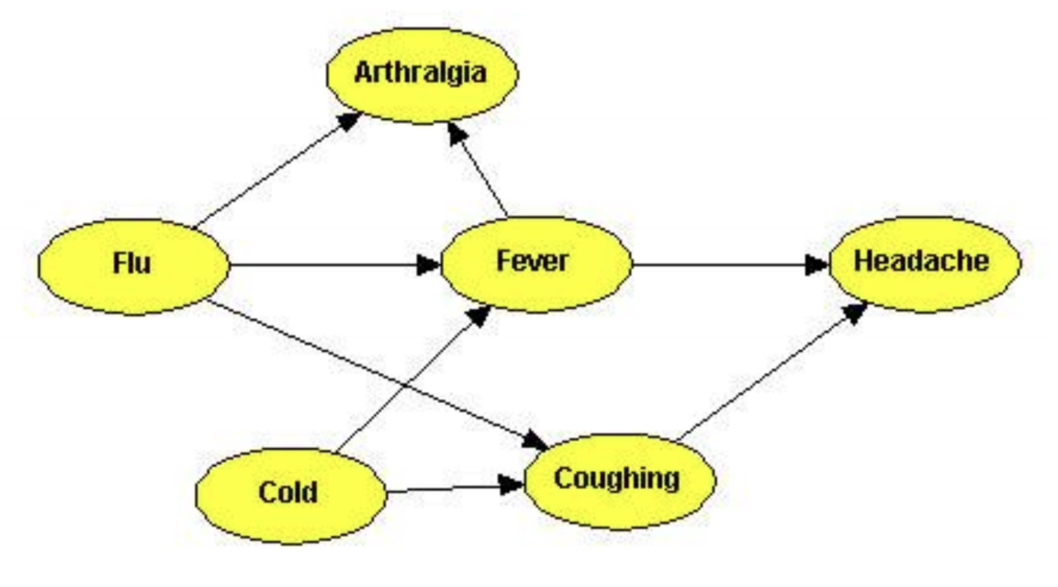

Figure 1: Example Bayesian network for medical diagnosis.

Source: <http://song.bayesian.net/index.php/Bayesian_net>

Probabilistic inference over Bayesian networks is a standard AI technique for medical diagnosis. Bayesian networks represent complex causal relationships between patient information, medical conditions, and symptoms. Probabilistic inference allows us to compute diagnostic queries, determining the likelihood of medical conditions given observed symptoms as evidence.Use the example Bayes net above as a prompt for the following questions.

# Question 1

Recall that the naive Bayes assumption is that no effects of a cause are also causes of each other. If two effects are correlated it is because they are related to the same, underlying cause. The naive Bayes model provides an alternative representation for diagnostic inference. Draw a Bayes net representing the naive Bayes model for diagnosing *Flu* given its symptoms (assume the symptoms of *Flu* are every successor of *Flu* in the Bayes net in Figure 1). Which model (the Bayes net in Figure 1 or the naive Bayes model that you’ve constructed) is a richer representation? That is to say, is there anything we can represent with one model that we cannot represent with the other model?

**Answer:**

While the naïve Bayes net constructed above gives a clear representation of the effects of a flu and linking them back. It fails to account for all the information in the Bayes net in Figure 1. For example, if a patient were to have coughing and a fever, the diagram above would suggest it is probably due to the Flu, however according to Figure 1, it could also be a cold. Additionally, having a fever can cause Arthralgia which is shown in Figure 1 and not above, suggesting that having all three symptoms of the Flu still wouldn’t mean that the patient has the Flu, while the naïve bayes model would assume they do.

# Question 2

|  |  |  |
| --- | --- | --- |
| *SICKt*−1 | *P*(*SICKt* = *T*|*SICKt*−1) | *P*(*SICKt* = *F*|*SICKt*−1) |
| T | 0.7 | 0.3 |
| F | 0.5 | 0.5 |

Table 1: Transition Probabilities

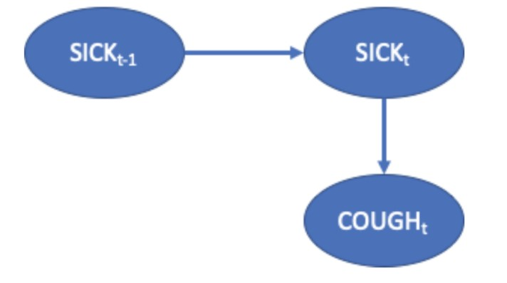

Figure 2: First Order Markov Dynamic Bayes Net

The traditional Dynamic Bayes Net has an unobservable random variable *Xt* that has a single parent of the value of *Xt*−1, which is the value of X at the previous time step. For example, SICK*t* is conditioned on SICK*t*−1. This can capture a relationship such as ”when one is sick, the probability is high that one is still sick at the next time step, and when one is not sick, one can become sick or stay well with equal probability”. See the image for an example. However, if one were to use this Bayes network to predict the future, the model may conclude that people become sick randomly and then stay sick. This setup does not account for second-order effects, such as: ”after one is sick for a while, the probability is high that one stops being sick”. A 2-Markov assumption states that an unobservable random variable *Xt* is conditioned on *Xt*−1 and *Xt*−2. **Using a time step equal to a week, draw a 2-Markov Dynamic Bayes Network that captures the intuition that one can become sick at any time**. When one is sick one is likely to remain sick unless they have been sick for two weeks, at which time they are likely to cease being sick. When one is sick, the probability of cough is high and when one is not sick, the probability of cough is low. **Show all the conditional probability tables; make up reasonable numbers to express the relationships described above.**

**Answer:**

*Transition Model:*

|  |  |  |  |
| --- | --- | --- | --- |
| *SICKt*−2 | *SICKt*−1 | *P*(*SICKt* = *T*|*SICKt*−1, *SICKt*−2) | *P*(*SICKt* = F|*SICKt*−1, *SICKt*−2) |
| T | T | 0.15 | 0.85 |
| F | 0.1 | 0.9 |
| F | T | 0.8 | 0.2 |
| F | 0.4 | 0.6 |

*Emission Model:*

|  |  |  |
| --- | --- | --- |
| *SICKt* | *P*(COUGH= *T*|*SICKt*) | *P*(COUGH= F|*SICKt*) |
| T | 0.9 | 0.1 |
| F | 0.2 | 0.8 |

*Dynamic Bayes Net:*

# Question 3

Medical diagnosis with Bayesian networks are currently used as a *decision support systems* by healthcare professionals. An expert can input patient information and observed symptoms, and the decision support system outputs a set of possible diagnoses with associated likelihoods, but the final diagnosis decision is up to the medical professional. Why should we require a human supervisor to accept or override the decision of the AI diagnosis system? Name two (2) potential sources of error or unaccounted for situations for these Bayes net diagnosis models that are mitigated by having a trained healthcare professional make the final diagnosis decision.

**Answer:**

We should have a human supervisor to accept or override the decision of the AI diagnosis since the probabilities set up in the Bayesian network are based on prior data collected allowing for the probability of a patient to have a diagnosis to be determined. However, this network may not consider other external factors that can lead to a false diagnosis. A potential source of error may be the system doesn’t account for the current pandemic or flu season and so the probability that certain symptoms lead to a different outcome are higher. Another source of error may be not considering a given patients medical history and family medical history, maybe a patient is more susceptible to a certain disease due to genetic factors or due to past experiences, this may cause the system to incorrectly diagnose the patient. In any case, the medical professional should use the system as an aid to hopefully verify his suspicions and conduct further testing otherwise.

# Question 4

Publicly accessible online services often use databases and symptom matching to inform users of possible medical conditions given a list of symptoms. These services do not provide diagnosis likelihoods. Could providing a free online service with Bayes-net-based medical diagnosis have negative impacts on human behavior? Could they have positive impacts? If you answered yes to either question, give one example. If you answered no, explain why not.

**Answer:**

I definitely think it could both have positive and negative impacts on human behavior given that the diagnosis likelihoods are not presented. In the case that certain symptoms lead to a fatal diagnosis, this may scare the patient resulting in potentially harmful situations. It could also cause stress which could lead to other potential health downfalls. However, it could also save lives, many times a quick diagnosis may tell a patient that they could potentially have cancer or some other disease, resulting in them acting and going to a doctor to get a second opinion. This could help many people find cancer cells or something else early and allowing for action to be taken.